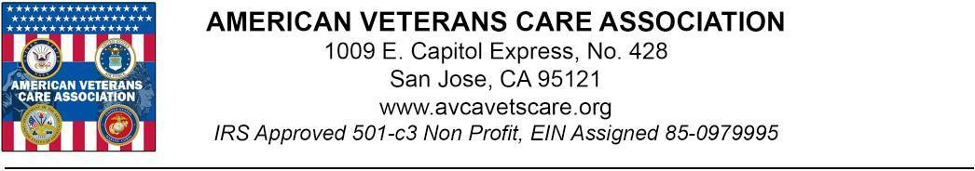
Date: __________ Winter Meals and Heating Assistance Program
Dear _________:

The whole staff of American Veterans Care Association are excited when you talked with _______________ on ____________and generously considering a $________pledge to help out in our Winter meal program to our Native and American Veterans in the Bay Area and Jemez Pueblo Reservation.

During this cold winter season where temperatures can be brutal in the reservation and in the Bay area, many of our Combat Veterans are struggling to provide basic meals and heating assistance on their own. Life seems to be not fair for these brave men and women who nearly sacrificed everything for our country. They need our HELP and we have to act now.

Thank you for providing HOPE to our Veterans. YOUR HELP will truly change lives in the communities that we are helping. We are truly and sincerely grateful for your help.

Your contribution will be used to purchase of Healthy Veggies and mash potato, Beans Healthy fruits, Nutritional supplements to many of these brave and extraordinary Veterans! You may rest assured that should your donation arrive past these holidays, your donation will be used to provide Prophane gas for our Veterans who are in need of heating assistance to warm their home.

This is an appeal for our Combat Veterans as we do not discriminate against race, color, religion (creed), gender, gender expression, age, national origin (ancestry), disability, marital status, sexual orientation, as long as they are American Veterans, we will respond to our calling: to help and serve their specific needs. We will not send you multiple mailings every week or month. We respect you and your contribution is valuable to us and the help it will provide.
Please take time now to write your check and send it along with the form on the bottom of this page. Please use the business reply envelope provided. This is very important and only YOU alone can make this work. No postage is necessary. We again thank you so very much for fulfilling your pledge.

Godspeed and Semper Fidelis,

David Paffrath, Ericha Fabay
Boiler Technician E3 U.S. Navy Ret. CEO, President, & AVCA Co-Founder

P.S. We do not receive any help or funding from any government institutions. We operate completely on the generosity of donors like you. Please send your donation in the business reply envelope provided today. It is important. Thank You!
- - - - - - - - - - - - - - - - - - - - - - - - - - - - - - - - - - - - - - - - - - - - - - - - - - - - - - - - - - - - - - - - - - - -

Please cut here and enclose in business reply envelope
Only YOU can make a difference and change lives!

I am a proud supporter of American AND Native American Veterans

Name ________________ Telephone number _____________________

Address _________________ Email ___________________________________

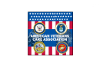
city/state/zip ______________
IRS Approved 501-c-3 Non-Profit
EIN Assigned 85-0979995
Donation Amount $ _______ www.avcavets.org

- Your Gift is Tax Deductible to the fullest extent allowed by law –

Name on the card ___________________________________
Credit card number __________________________________ CVC _________ Expiration Date ____/____
Donation Amount $ _______
Credit card used ⬜ VISA ⬜ MASTERCARD ⬜ AMEX ⬜ DISCOVER
Signature: ___________________ Pledge Date: ___________________ EJ1

Thank you and "Semper Fidelis" AMERICAN VETERANS CARE ASSOCIATION registered and licensed in all states!

